|  |
| --- |
|  |
| 新概念 3 册 |
| Lesson23 |

Lesson 23 One man’s meat is another man’s poison

**poison ['pɔizən]**

**n. 毒药**

rat poison

poison gas poison arrows

one man’s meat is another man’s poison

The reader's hair stands on end when he reads in the final pages of the novel that the heroine, a dear old lady who had always been so kind to everybody, had, in her youth, poisoned every one of her five husbands.

The ring brought to Gollum unnatural long life. For 500 years it poisoned his mind.

poisonous toxic noxious

Carbon monoxide is a colorless, odorless and noxious gas.

delicacy ['delɪkəsɪ]

**n. 美味，佳肴**

delicious tasty luscious yummy yucky

repulsive [ri'pʌlsɪv] adj. 令人厌恶的

repulsive smell / behavior repulse

The tourists were repulsed by the filthy conditions. repel ➔ repellent

revolt ➔ revolting disgust ➔ disgusting **turn [tɜ:n]**

v. 感到恶心，翻胃

The food makes my stomach turn. The food turns my stomach.

The food disgusts / nauseates / sickens me. The food repels / revolts my stomach.

The food makes me feel sick / lose my appetite. The food makes me throw up / vomit.

fry [fraɪ]

**v. 煎，炸**

I have another fish to fry. frying pan

out of the frying pan into the fire fries / French fries

May I take your order? What’ll it be for you?

I need a double cheese burger, a fries, and a small coke. I need a No. 1 combo.

For here or to go? Here. / To go.

That’s five dollars and fifty cents. Here you are. / Here you go.

This is your change and receipt. Can I have some ketchup?

It’s on the service counter over there. Thank you!

You’re welcome. Have a nice day!

associate [ə'səʊʃɪeɪt]

**v. 联系；联想**

**associate A with B**

We often associate wealth with happiness, yet this is not always the case.

connect A with / to B link A with / to B relate A with / to B

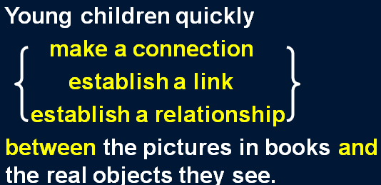make a connection *between A and B* establish a link *between A and B* establish a relationship *between A and B*

despise [dɪ'spaɪz]

**v. 鄙视**

Do not despise your enemy. scorn …

hold … in contempt look down on / upon …

For in a university, science majors look down on humanities majors, foreign language majors on Chinese majors, Chinese majors on philosophy majors, philosophy majors on sociology majors, and sociology majors on education majors. Since education majors have no one to look down on, they can only despise the professors in their own department.

— ‘Fortress besieged’ by Zhongshu Qian

respect … esteem …

**honor … revere …**

**look up to …**

**hold … in high esteem**

Because of their achievements they were held in high esteem. One man’s meat is another man’s poison.

There’s no accounting for taste.

—Why did she marry someone like that?

—One man’s meat is another man’s poison. / There’s no accounting for taste.

People become quite illogical when they try to decide *what can be eaten* and *what cannot be eaten*.

People become quite illogical when it comes to deciding what can be eaten and what cannot be eaten.

If you lived in the Mediterranean, *for instance*, you would consider octopus a great delicacy.

与现在事实相反的“if” 型的虚拟语气

**if + S. + did / were , S. + would / should / could / might + do**

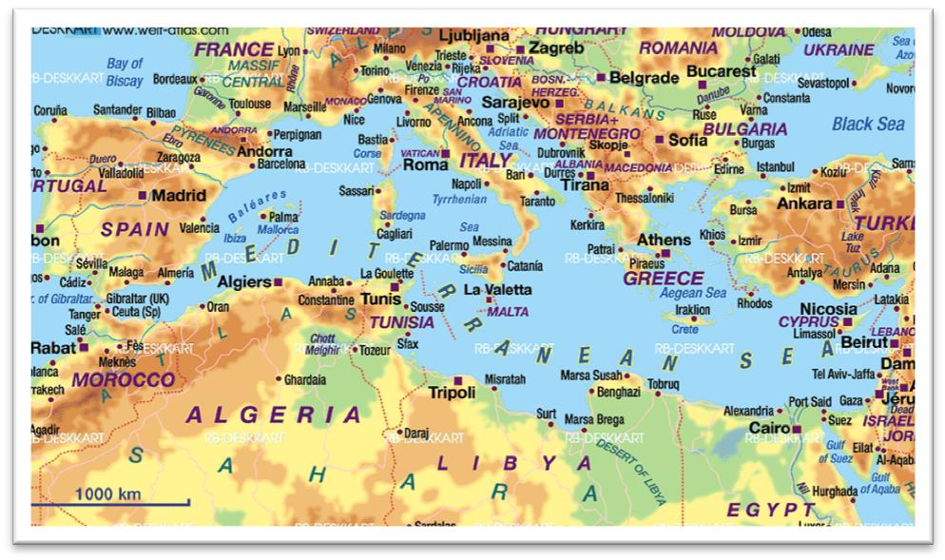the Mediterranean

southern Europe

Italy Spain Greece … the Mediterranean

the Near East the Middle East the Far East

for instance for example e.g.

如果你住在北京，你就会把豆汁儿 (Douzhir) 当作一道美味佳肴。

If you lived in Beijing, you would consider Douzhir a great delicacy.

如果你住在中国东北地区 (the Northeast of China), 你就会非常喜欢滑冰。

If you lived in the Northeast of China, you would consider skating a great pleasure.

such as / like

People’s ability to do the test is influenced by factors such as / like age, sex, and ethnic background.

take … for example

Take me for example, I’ve never relied on other people for help.

be a case in point

Lack of communication causes serious problems and their marriage is a case in point.

by way of illustration

Other countries have totally different laws on abortion. By way of illustration let us look at the cases of Germany and Japan.

to name but a few

So many industries have been hit in the recession. Steel, coal, construction, to name but a few.

… find it repellent / disgusting / revolting.

On the other hand, your stomach would turn at the idea of *frying potatoes in animal fat*—*the normally accepted practice in many northern countries*.

on the one hand ... on the other (hand)…

On the one hand I'd like a job which pays more, but on the other (hand) I enjoy the work I'm doing at the moment.

for one thing … for another …

"Why won't you come to New York with me?"

"For one thing, I don't like flying, and for another, I can't afford it."

not that …, but that …

Not that I love Caesar less, but that I love Rome more.

— Shakespeare ‘Julius Caesar’

Not that I love you less, but that I love liberty more.

Not that I love my teacher less, but that I love truth more.

at the … of …

She screamed at the sight of the ghost.

She trembled at the thought of the murder. She fainted at the news of her father’s death. She wept at the mention of the accident.

Most of my friends live in the city, yet they always go into raptures at the mere mention of the country.

practice: custom / tradition

a bad practice 不正之风

The sad truth is that most of us have been brought up *to eat certain foods* and we stick to them all our lives.

sad: unfortunate / regrettable He made a sad mistake.

I guess I set up the video camera to try and entice Joey. But sadly I could not be enticed.

a happy discovery the happy few **bring up / raise sb.**

He was brought up / raised by his step-mother. be brought up to do 从小就……

We have been brought up to fear insects.

I have been brought up to believe that it is proper to make contributions to charity.

And perhaps all those successful college graduates would have been successful whether they had gone to college or not. This is heresy to those of us who have been brought up to believe that if a little schooling is good, more has to be much better.

certain foods

= certain kinds of food

stick to sth. keep to sth.

throughout our lives

receive + n. 受到……；得到……；遭到……

These young people, who love the peace of the mountains, always receive a warm welcome at St. Bernard’s monastery.

receive praise receive abuse receive support

receive good education receive adequate treatment receive a warm welcome

This exhibition received a great deal of attention in the press, for though the pictures were supposed to be the work of famous artists, they had in fact been painted by Dickie.

Nothing is more shameless than fooling the public.

There is no quicker method of disposing of patients than by giving them what they are asking for. Nothing can be compared, he maintains, with the first cockcrow, the twittering of birds at dawn, the sight of the rising sun glinting on the trees and pastures.

But nothing can match them for speed and comfort.

in various parts of the world all over the world throughout the world

**the world over**

There are countless people who, ever since their early years, have learned to associate snails with food.

The big clock which used to strike the hours day and night was damaged many years ago and has been silent ever since.

You know how she feels about you. It’s been the same way ever since we were kids.

… have learned to connect snails with / to food.

… have learned to link snails with / to food.

… have learned to relate snails with / to food.

… have made a connection between snails and food.

… have established a link between snails and food.

… have established a relationship between snails and food.

… of one’s own 某人自己的……

…, but they lead mysterious lives of their own as well.

…, he has no private / personal garden. collect: gather

Gather rose-buds while you may.

金缕衣 杜秋娘劝君莫惜金缕衣劝君惜取少年时花开堪折直须折莫待无花空折枝

The idea never appealed to me very much, but one day, *after a heavy shower*, I happened to be walking in my garden when I noticed a huge number of snails *taking a stroll on some of my prize plants*.

appeal to sb.

The quiet life of the country has never appealed to me.

In spite of national differences, certain funny situations have a universal appeal.

appeal (to sb.) for sth.

They are appealing to local businesses for sponsorship.

As the crisis grew worse, the government appealed for unity.

an appeal for help / food / extra staff …

It's missing head happened to be among remains of the fifth century B.C.

主句 (进行时 / be about to do) + when ... “when”应译为“这时”或“突然”

I was having dinner when the phone rang. I was about to leave when the phone rang.

He was still mumbling something about hospitals at the end of the party when he slipped on a piece of ice and broke his left leg.

The Karen had been sailing in a convoy to Russia when she was torpedoed by an enemy submarine.

The morning passed rapidly and Frank was about to leave when he noticed a large packing case lying on the floor.

**take a stroll / walk** 无边落木萧萧下不尽长江滚滚来

prize: valued / treasured

One of Mary's prize possessions was a little white lamb which her husband had given her.

Acting on a sudden impulse, I *collected* several dozen, *put* them in a paper bag, and *took* them to Robert.

George took off his jacket, rolled up his sleeves and pushed his right arm through the drain cover. delighted: very pleased

be delighted / pleased *with … / to do …*

I felt especially pleased with my wonderful bargain―until I got back to the ship. But I was extremely pleased with myself I had traced the cause of the trouble.

When I was a teenager, I felt that I was just young and uncertain―that I was a new boy in a huge school, and I would have been very pleased to be regarded as something so interesting as a problem.

I left the bag in the hall and Robert and I went into the living room where we talked for a couple of hours.

Having left the bag in the hall, ???

Robert and I went into the living room and we talked for a couple of hours *there*.

about 2 hours

**nearly 2 hours**

**roughly 2 hours**

**some 2 hours**

approximately 2 hours 2 hours or so

I had forgotten all about the snails when Robert suddenly said that I must stay to dinner.

… when Robert suddenly proposed that I *(should) stay* to dinner.

stay to / for + 三餐名

Won’t you stay to / for dinner?

main dish / course

… and I unwillingly followed Robert out of the room.

… and I followed Robert out of the room with reluctance.

*To our dismay*, we saw that there were snails everywhere: they had escaped from the paper bag and had taken complete possession of the hall!

sImagine their dismay when they found a beautifully-cooked wallet and notes turned to ash!

**take possession of … 占据…… be in possession of … 拥有……** Once bitten, twice shy.